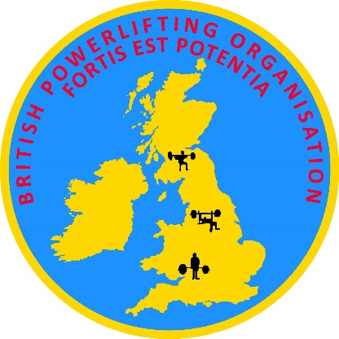
2020 BPO BRITISH OPEN CHAMPIONSHIPS
POWERLIFTING, BENCH PRESS & DEAD LIFT
SINGLE LIFT BENCH PRESS AND DEAD LIFT RECORD BREAKERS
Venue: Bobby’s Gym, 30 Sandling Rise, William Barefoot Drive
Eltham, SE9 3AU London ENGLAND
Date: Sunday 13th December
Meet Director: Barry Davis (07979 035596)
Entry to BPO by NO later than 15th November
ENTRY FORM (fill in ONE form for all event(s) entered for each participant)
Your full name: (First)  Address:  E-Mail: | (Last)  Telephone No:
TOWN - CITY
Age Category (Circle appropriate category)  M40+, M45+, M50+, M55+, M60+, M65+, M70+, M75+, M80+ | Teenager 15-19 | Junior 20-23 |  | Open | Master M +
Date of Birth (Proof of age required at weigh-in) | DOB AGE:
Entering competition in (Circle)  RAW, CLASSIC, SINGLE PLY, MULTI PLY | Powerlifting  ( 3 lifts ) |  | Single Lift  Bench Press |  |  | Single Lift  Dead Lift
Weight Class (Circle the appropriate Category)
Men’s | (56)  (60)  (67,5) | (75)  (82,5)  (90) | (100)  (110) | (125)  (140)  (140+)
Women’s | (48)  (52) | (56)  (60) | (67,5)  (75) | (82,5)  (90)  (90+)
I hereby agree to enter this competition on the following terms:
That I am a member of the BPO or an Organisation affilated to EPC & WPF. If not, entry fee is 50% additional.
That I take part entirely at my own risk and that there shall be NO liability whatsoever on the part of the Meet Director, the British Powerlifting Organisation, its officers, employees or agents for any loss, damage or injury suffered by me, howsoever caused.
That I know of no reason why I should not take part on the grounds of ill health.
I enclose my £55 pounds sterling entry fee for EACH entry, payable to the British Powerlifting Organisation, which is non-refundable.
All entry forms and fees to be sent to the British Powerlifting Organisation, to be received by NO LATER than the 15th November 2020
I agree to produce at the weigh-in proof of my age by passport or photographed driving licence.
I agree to abide by all the WPF rules for Powerlifting, Bench Press and Dead Lift.
I hereby waive, rele5se, and discard any and all claims for damages, death, personal injury or property damage which I have or which may hereafter occur to me as a result of my participation in said event. This release is intended to discharge in advance, the British Powerlifting Organisation, the Executive Committee, Barry Davis, Meet Director, Bobby’s Gyms, and any other unnamed sponsors, officials, agents, or representatives of these individual organizations from and against all liability arising out of or connected in any way with my participation in said event, even though that liability may arise out of the negligence or carelessness on the part of persons or entities mentioned above. I understand that I am not covered for any personal injury and/or property damage under any medical or liability insurance policies of any of the aforementioned parties or any other sponsors. It is further understood and agreed that this waiver, release and assumption of risk is to be binding on my heirs and assigns.

Signature of Competitor: ____________________________________________Date___________________________________________

Signature of Parent/Legal Guardian: __________________________________Date:__________________________________________
If competitor is under 18 years old
RETURN ENTRY FORM(S) AND FEES TO : BRITISH POWERLIFTING ORGANISATION
“Lavieville” 45 Oaktrees, Ash, Aldershot, GU12 6QS Great Britain
Tel: 0044(0)7770 757321 - E-mail: davidtcarter@live.co.uk Web:.www.wpfpowerlifting.ru

